Vassar Aikido Club
Spring Seminar Series
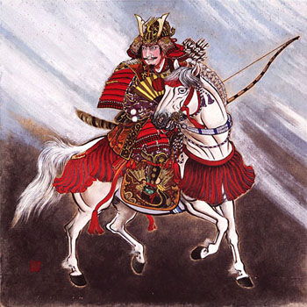

Saturday
April 11, 2009
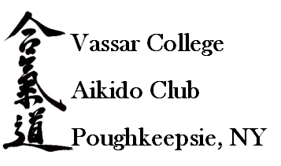

Schedule of Events

This version: March 16, 2009

Saturday, April 11th
10:30 – 11:45 Registration, Warm-up
11:45 – 1:00 Combat style Judo throws: Jeff Stokum Sensei
10:45-12:15 Jiao Shou: Scott Miller Sensei
1:00 – 2:00 Lunch (provided)
2:00 – 3:15 Jujitsu's Dynamic Micro-Locking: John Borter Sensei
3:15-5:00 Aikido: Sean Flynn Sensei
5:00 – 6:30pm Dinner

*All elements subject to change

Instructor Biographies:
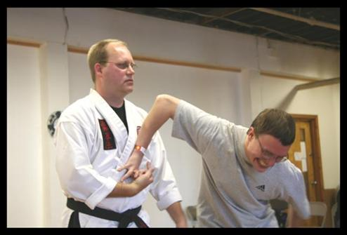
John Borter Sensei holds the rank of 5th Dan with blackbelts in Small Circle Jujitsu, US Jujitsu, Hapkido, Combat Hapkido, Tae Kwon Do, and Kyusho-Jitsu as well as extensive experience in other styles and systems. He is the the head instructor of the Stratton Air National Guard Jujitsu Club in Scotia, NY and the Jujitsu School of Self-Defense in Saratoga Springs NY. He also holds Instructor Certifications in Military Combatives and Police Defensive Tactics, and is an internationally certified Self-Defense Instructor. He is the director and head instructor for the PressurePoint Self-Defense and PressurePoint Defensive Tactics systems widely taught to the general public, law enforcement, security, and military personnel. He was inducted into the World Martial Arts Hall of Fame in 1997 in recognition for Outstanding Contributions to the Martial Arts, and named 2005 Jujitsu Instructor of the Year and 2007 Master Instructor of the Year for the Valadez Kenpo Association. He is widely sought for his popular and successful Small Circle Jujitsu seminars.
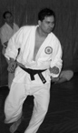
Sean Masaki Flynn Sensei is an Assistant Professor of Economics at Vassar College and head Sensei of the Vassar College Shodokan Aikido Club. Sensei Flynn has studied Aikido extensively in Japan, is the author of Understanding Shodokan Aikido. Flynn Sensei currently serves on the Board of Directors of the Japan Aikido Association, USA.
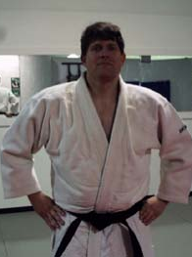
Jeff Stokum Sensei is presently a Sandan (third degree black belt) and has over 15 years teaching experience on Judo. At age 22, he practiced on the United States Naval team for over a year. After an honorable discharge from the Navy he moved to Poughkeepsie and continued his studies under Ted Wolf at the Center for the Martial Arts. In addition, he taught judo as a mini course at Vassar College. In 1997 he moved to Albuquerque New Mexico to study Oriental Medicine. There, he studied and taught Judo at the Sandia Judo Club until 2000. Upon returning to Poughkeepsie, he started teaching classes again at the Center for the Martial Arts. In 2004, he was nominated to the position of head coach for the Hudson Valley region Empire States Games team (a position he currently holds) and started the Hudson Valley Judo Club at the Poughkeepsie YMCA. In January 2009, the Hudson Valley Judo Club relocated to Vassar College where classes are presently held on Wednesdays, Fridays, and Sundays from 6-8PM. All ages and abilities are welcome.
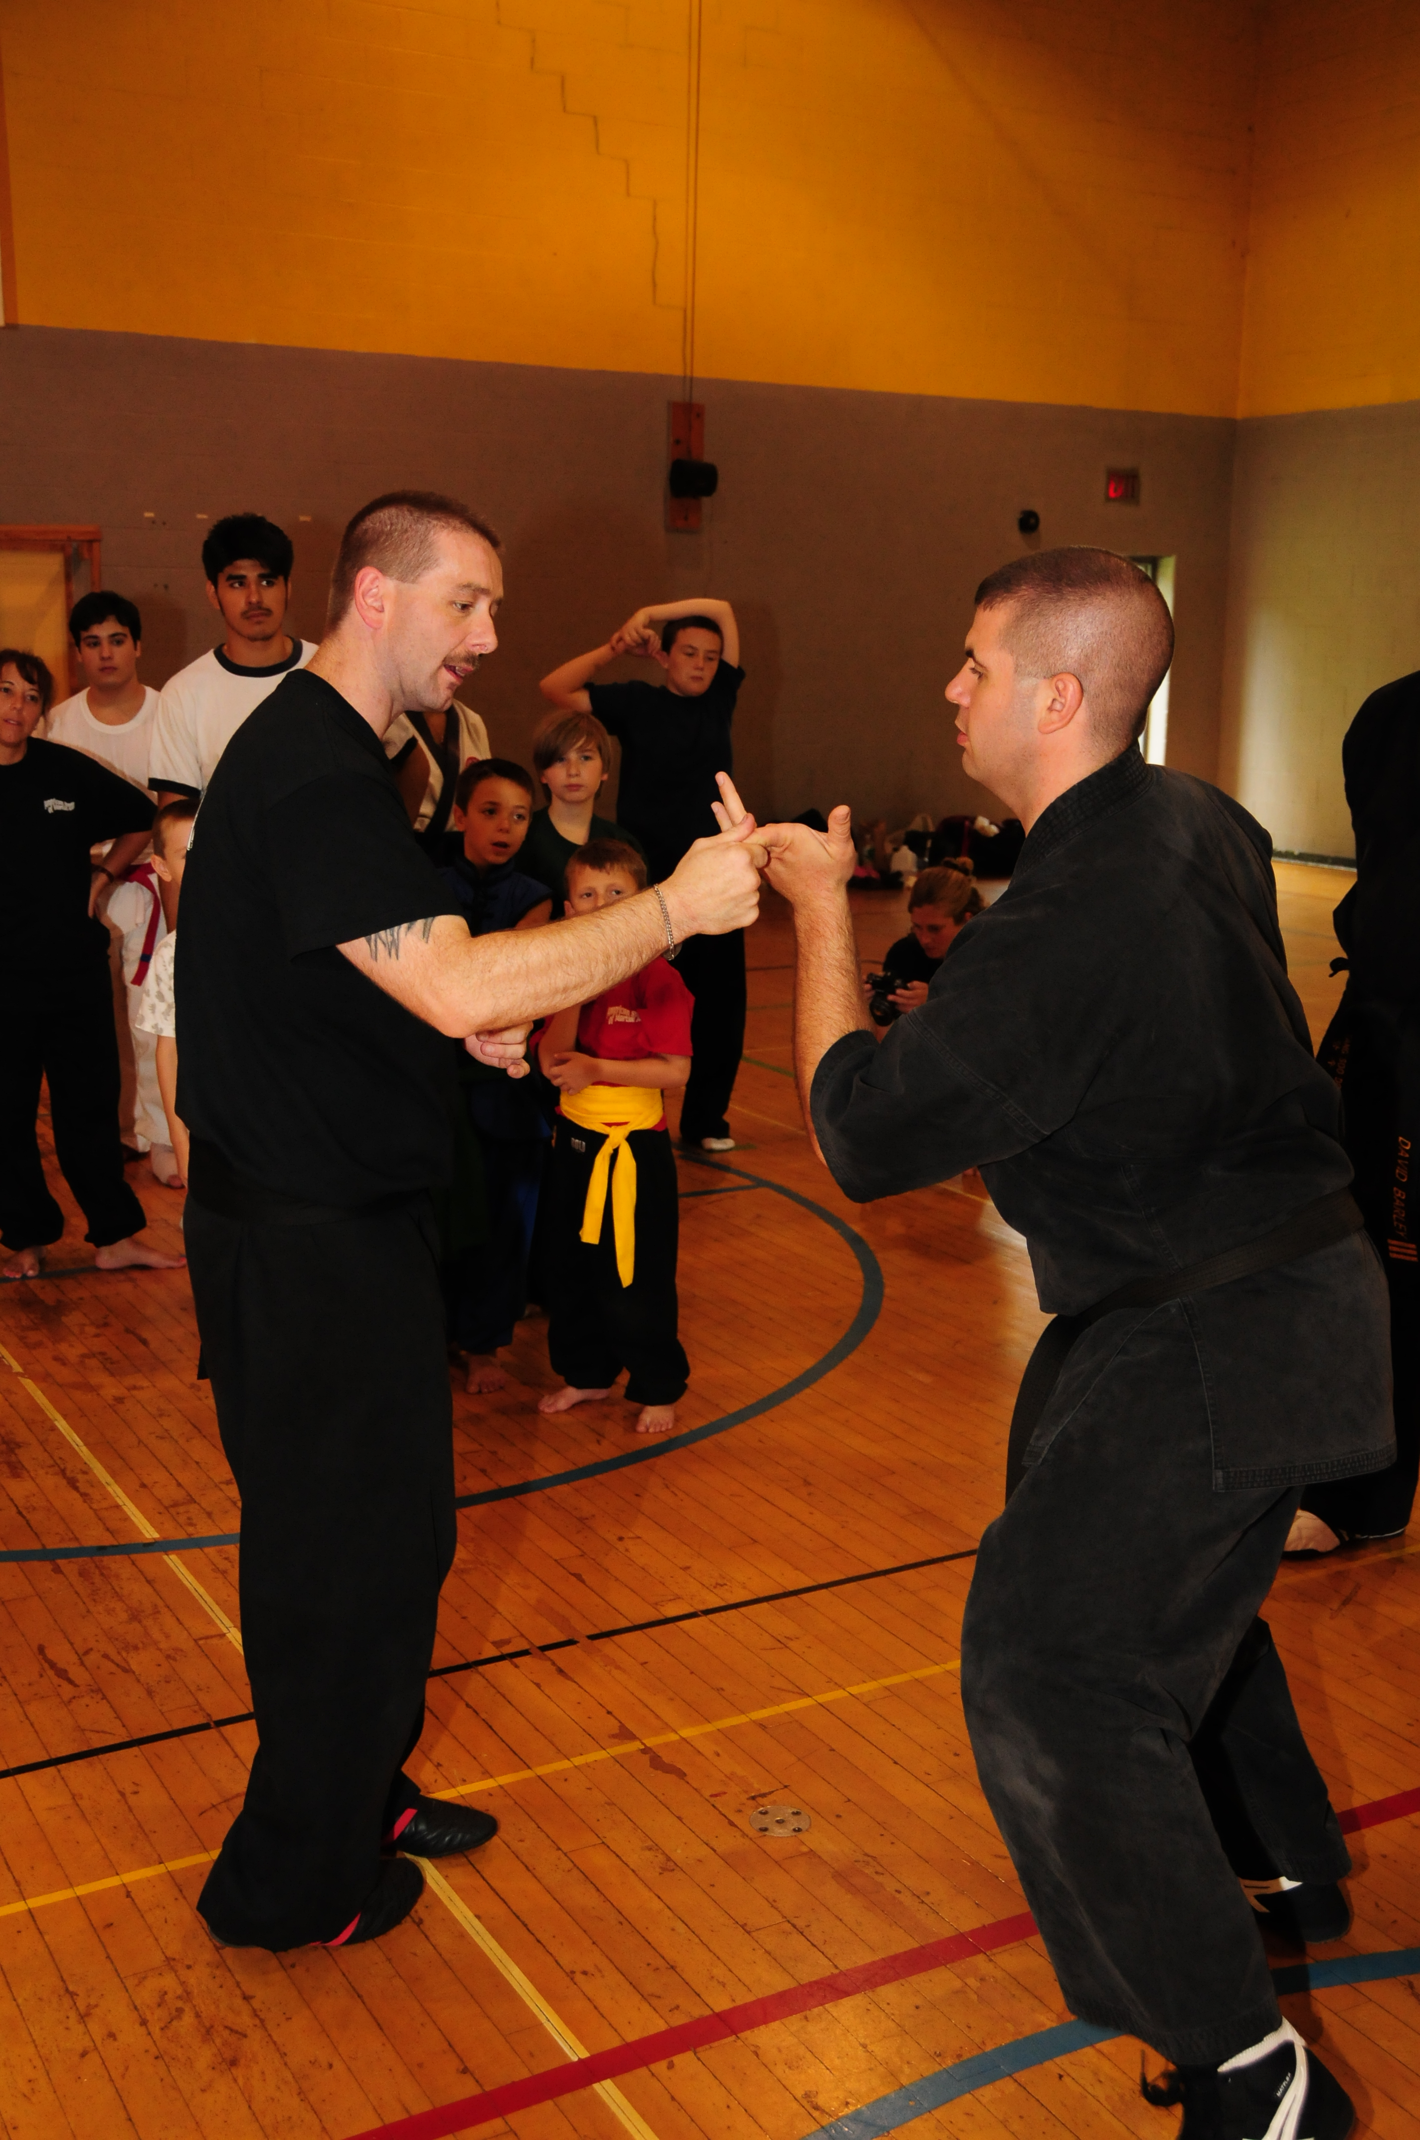
Sifu Scott Miller began his training in 1979 in Martial Arts. He holds Blackbelts/sashes in:
- Jiao Shou - 6th Degree Black
- Soo Bahk Do- 3rd degree Black (midnight blue)
- Tae Kwon Do- 3rd Degree Black
- Shotokan - 1st Degree Black
- Nokahuro Jujitsu - 1st Degree black.
Other areas of study include: Choy Lay Fut, Aikido, Wing Chun, Brazilian Jujitsu, Tai Chi Chuan, Pekiti Tirshia, American Kickboxing, Kempo, & Baguazhang. Understanding that all styles and systems of Martial Arts have something to offer students, Sifu Miller wanted to create a system that was very well rounded, yet could change with the times. Hence, Jiao Shou was born. He has competed in many Martial Arts and Kickboxing tournaments all over the United States, winning over 500 events. He was inducted into the Black Belt Hall of Fame as Kung Fu Instructor of the Year in 2003. After coming out of a lengthy retirement was awarded National Sparring Champion of 2004. In 2007 Sifu Miller co-founded the Independent Martial Arts Council, to bring higher quality Martial Arts to those searching for something more. His goal is to share the Martial Arts with as many people possible in hope that Martial Arts can improve their life the way it has his.

Standard Map: http://www.vassar.edu/visitors/map.html

Driving Directions:

From the Taconic State Parkway
Exit at Route 55 westbound. Proceed six miles west to a left turn onto Route 376 Extension/Van Wagner Road (which becomes Raymond Avenue), and proceed less than 1 mile to Vassar. A Gothic stone archway, the main entrance, is on the left.

From the New York State Thruway Northbound
Use Exit 17 (Newburgh) and take I-84 eastbound across the Newburgh-Beacon Bridge to Exit 13 (Route 9 north). Drive 9.5 miles north from the intersection of I-84 and Route 9 to the exit for Spackenkill Road (Route 113). Proceed about 0.5 miles on Spackenkill Road. Turn left at the second traffic light onto Wilbur Boulevard. Turn right when Wilbur ends at Hooker Avenue. Turn left at first traffic light onto Raymond Avenue. Enter the college through the stone archway on the right.

From the New York State Thruway Southbound
Use Exit 18 (New Paltz) and proceed east on Route 299. Turn right onto Route 9W south. Exit onto Route 44/55 east. Cross the Mid-Hudson Bridge and continue on Route 44/55 east for approximately 2 miles. Turn right onto Raymond Avenue. Enter the college through the stone archway on the left.

From Route 9 Northbound
Drive 9.5 miles north from the intersection of I-84 and Route 9 to the exit for Spackenkill Road (Route 113). Proceed about 0.5 miles on Spackenkill Road. Turn left at the second traffic light onto Wilbur Boulevard. Turn right when Wilbur ends at Hooker Avenue. Turn left at first traffic light onto Raymond Avenue. Enter the college through the stone archway on the right.

From Route 9 Southbound
Exit at Spackenkill Road (Route 113). Proceed about 0.5 miles on Spackenkill Road. Turn left at the second traffic light onto Wilbur Boulevard. Turn right when Wilbur ends at Hooker Avenue. Turn left at first traffic light onto Raymond Avenue. Enter the college through the stone archway on the right.

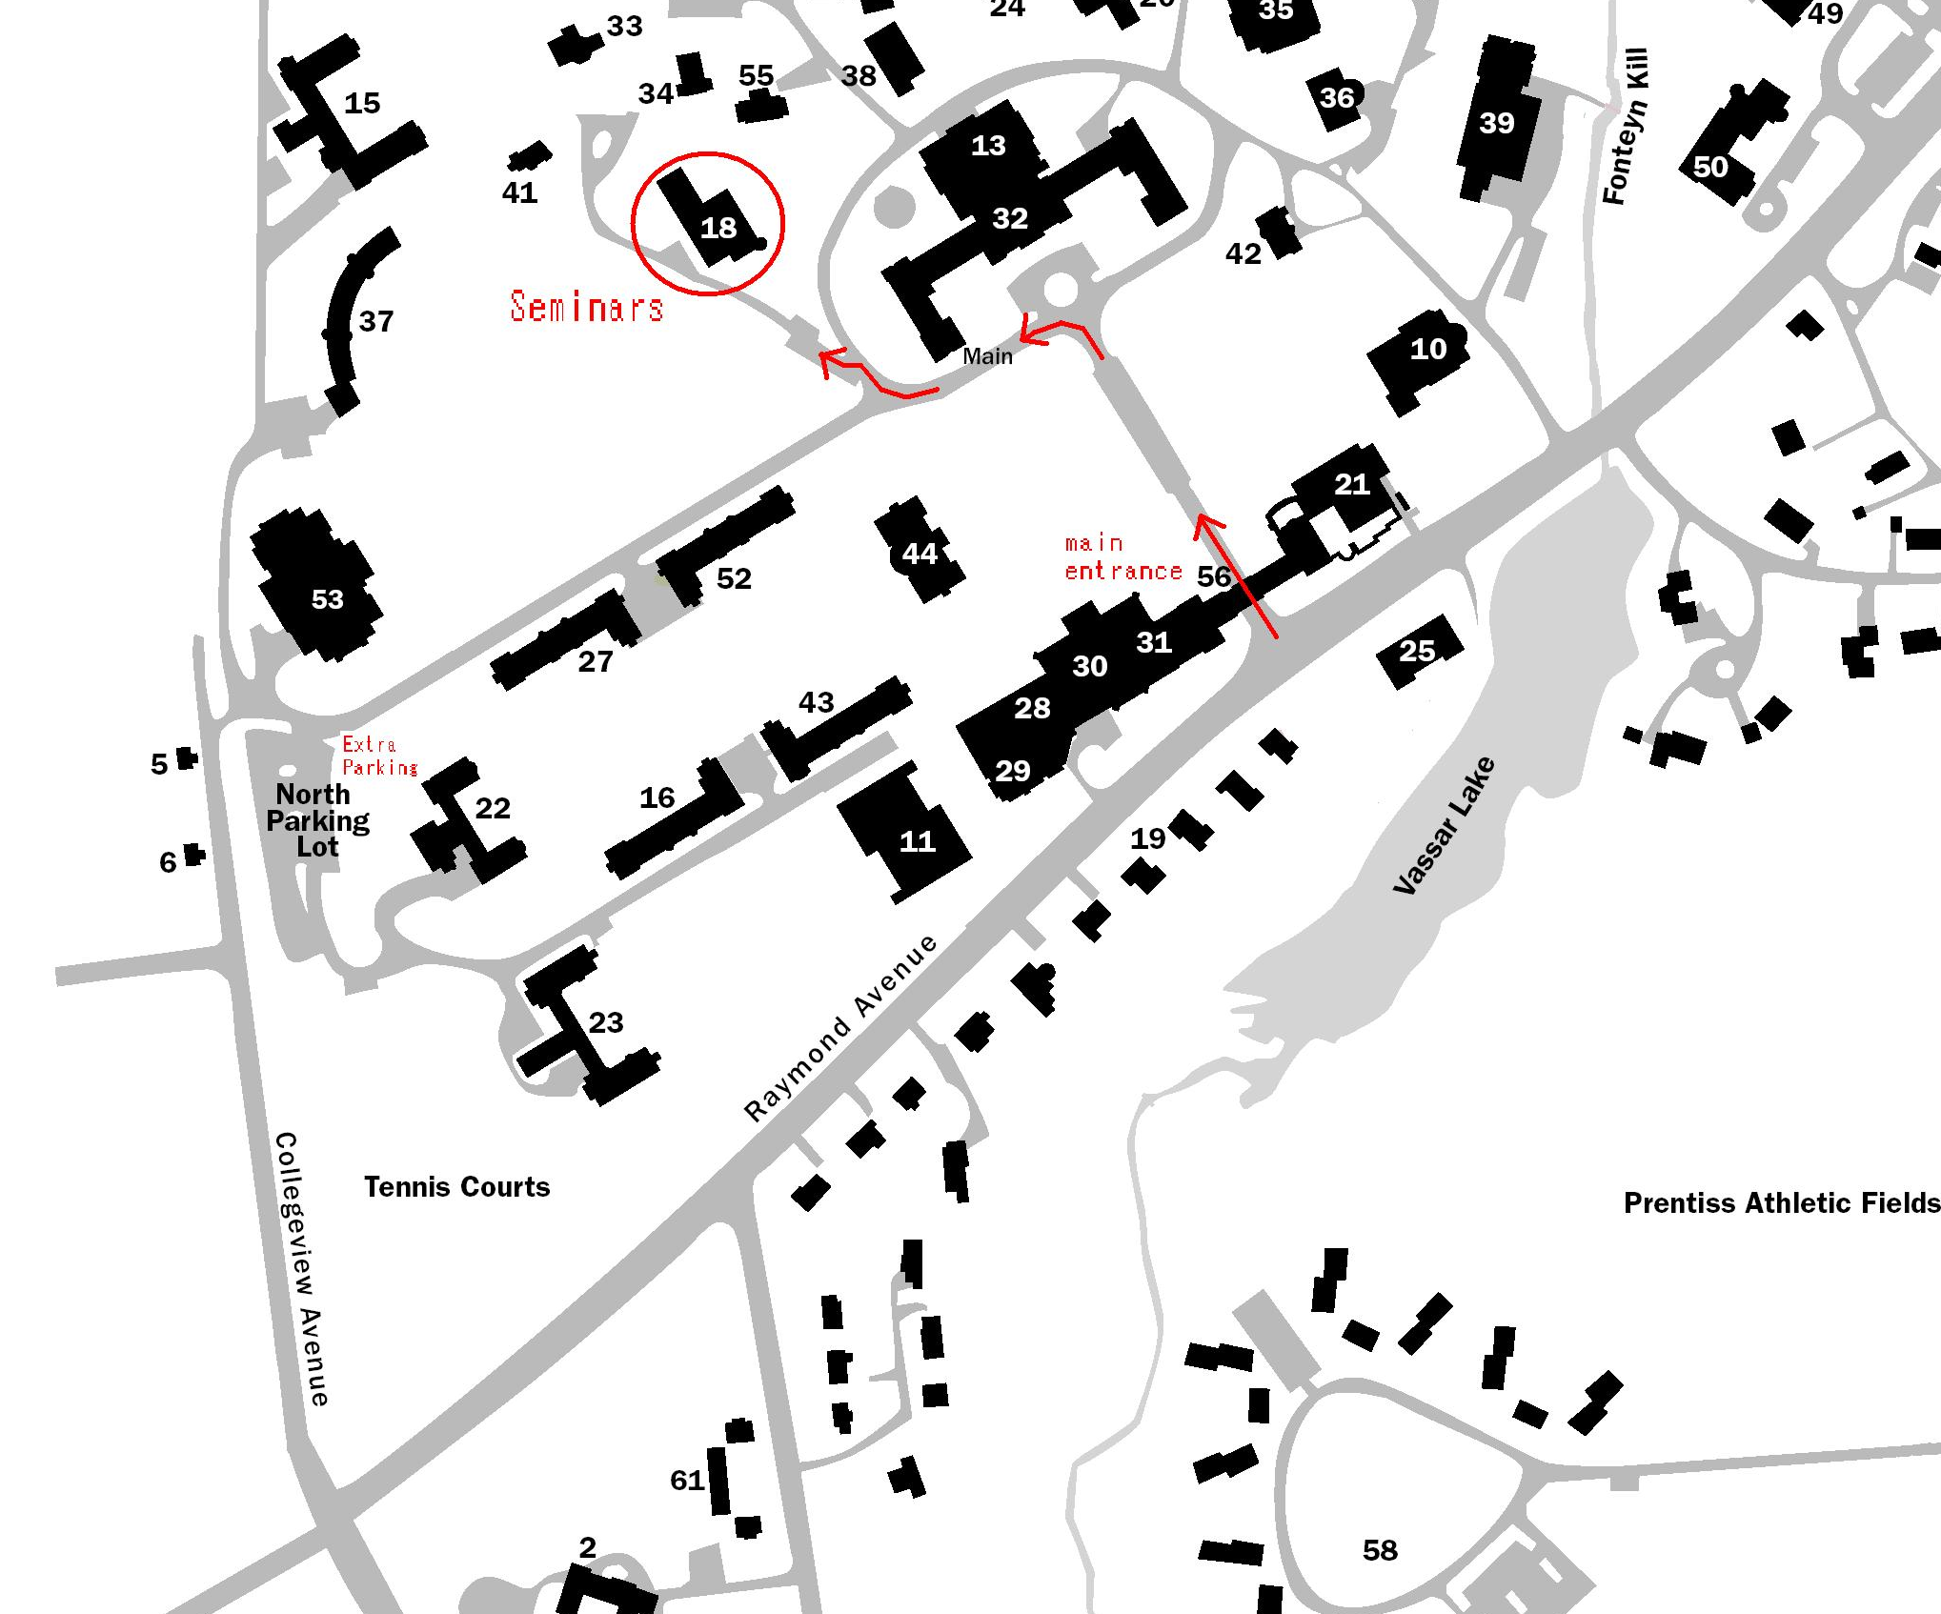
Seminars are held in the Aula portion of Ely Hall. After entering the main entrance archway take the first left. At the stop sign, take a right and immediate left into a parking lot. Ely Hall is distinguished by a large round turret and arched brick entranceway.

