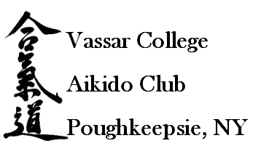
Saturday, April 24, 2010
Kenyon Hall (10:00 - 5:30)
Vassar Aikido Club
Spring Seminar Series
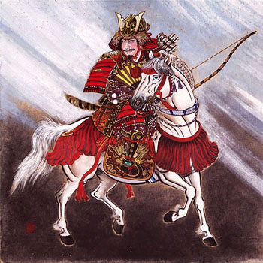
Kyoshi Joe Mansfield – 40 years of experience in arts such as Okinawa- Te Ryute Renmei, Small Circle Jujitsu, and Filipino stick and knife fighting, under instructors including Grandmasters Taika Oyata, Wally Jay, and Remy Presas.
John Borter Sensei – Holds blackbelt ranks in Jujitsu, Tae Kwon Do, Hapkido, Combat Hapkido, and Kyusho-Jitsu, with instructor certifications in Military Combatives, Police Defensive Tactics, and Self-Defense.
Steven Pearlman Sensei - founder of Genri-Ryu Bujutsu, director of The Saratoga Martial Arts Festival (SMAF), and author of The Book of Martial Power as well as two DVDs on open-handed combatives.

$20 per person (includes lunch & dinner)
$15 per person (with student I.D.; includes lunch and dinner)

Individuals with disabilities requiring accommodations or information on accessibility should contact the Campus Activities Office, (845) 437-5370. Questions may be directed to Jeff at: jestickle@vassar.edu
To sign up to our mailing list, go to http://lists.vassar.edu/mailman/listinfo/ and select Aikido

This event is not a competition and will only incorporate light touch activities in a friendly, cooperative, and supportive atmosphere. We invite and welcome anyone, of any rank, from any martial arts school to attend this event.

